Market Segmentation Segmentation for Bio-tech Start-up

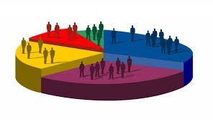

**Team Members:**

**Alok Ranjan**

# Problem Statement

Our team has to work under a Bio-Tech Startup, who is going to launch its Home Checkup Service with Online Booking offering the following initial services.

1. Full Body Checkup with a Bio-Tech Device based on Blood Samples
2. Online Health Techs offering :

i. Diabetes checkup device, ii. Blood Pressure checkup device, iii. Vitamins deficiency checkup device

# Data Collection

Most of the Data is primarily collected from Kaggle http://data.gov.in/ https://data.worlbank.org

# Segmentation Criteria

The term segmentation Criteria relates to the nature or the type of information used for market segmentation, unlike the segmentation variable which means the variable in empirical data in common sense segmentation for splitting the sample into market segments. In Segmentation we usually find the identifiable characteristics of individuals in the data sample and segmenting them into a same cluster and analyze the common interest needs to maximize the organizations profits. Segmentation Criteria is an important factor in market segmentation as well. The four main types in segmentation criteria are Geographic Segmentation, socio-demographic segmentation, psychographic segmentation and behavioral segmentation.

## Geographic Segmentation

In Geographic Segmentation the key criteria to form market segments is the geographic location or the residence of the customer. There are some specific advantages of doing geographic segmentation, they are, we can segment down all the customers in that particular area, do promotions which are meaningful in that area and even run adds in news-papers, television, etc. in that local area. The only key disadvantage is that it not always the case that all the people residing in the same location will have same opinions and preferences in the products.

## Socio-Demographic Segmentation

Socio-Demographic Segmentation criteria includes parameters like age, gender, education, income, etc. For ex, while buying cosmetics criteria associated is gender, while buying branded and luxury items criteria associated is income, while planning on vacation destination criteria associated is age (i.e., if people go in couple the vacation destination will be different if people going with children, then the vacation destination is different). The socio-demographic segmentation at times with better data can give us the better market segments and gives us the clear clarity on the who the customer is, this is achievable provided better data that provides sufficient insights about who the customer is and the market segments. But in many cases, socio-demographic segmentation would not be the best fit for product preferences.

## Psychographic Segmentation

For making market segments using the Psychographic segmentation the criteria is the Psychological criteria for grouping people.

Parameters like interest, beliefs, aspirations, preferences, benefits, etc. can be used to define psychological criteria. Psychographic segmentation is more complex by nature compared to Geographic Segmentation and Socio-Demographic segmentation because, we cannot find a single fixed parameter for insights for better segmentation, there are a lot of factors effecting the psychographic criteria and the factors are different in each person. Therefore, we must use a lot of segmentation variables. And the main advantage that psychographic segmentation has is that clustering a common set of customers based on psychographic criteria for maximizing profits. For ex., people who want to go on a vacation and has a preference for attending historic pilgrims can be clustered and can be taken together which can reduce cost for company and maximize the profit as well.

## Behavioral Segmentation

In Behavioral segmentation we can directly find similarities in behaviors of customers. There can be many useful implementations possible for doing market segments. Behavioural segmentation criteria depend on the way visitors interact with the website. Some data depends on their immediate online behaviour and giving positive feedback while other data depends on their past offline behaviour or negative feedback.

# Pre-Processing Data before performing Segmentation

1. Categorical Variables

Two pre-processing procedures are often used for categorical variables. One is merging levels of categorical variables before further analysis, the other one is converting categorical variables to numeric ones, if it makes sense to do so. Merging levels of categorical variables is useful if the original categories are too differentiated (too many).

1. Numerical Variables

In distance-based methods of segment extraction, the range of values of a segmentation variable determines its relative influence. If one of the segmentation variables is binary (with values 0 or 1 indicating whether or not a customer views on the product of fast food), and a second variable indicates the expenditure in dollars per person per day (with values ranging from zero to $1000), a one-dollar difference in spend per person per day is weighted equally as the difference in liking to dine out or not.

1. Univariate Variables

We take one feature and based on that we will try to classify what the output is going to be. In McDonald’s dataset, we took age as feature and classified based how much they are liked. From our data all the persons who gave positive feedback ‘4’ and above their age is around ‘20’ and the data are fit (overlapped) one guy from age.

1. Bivariate Variables

Bivariate analysis is slightly more analytical than Univariate analysis. When the data set contains two variables and researchers aim to undertake comparisons between the two data set then Bivariate analysis is the right type of analysis technique.

1. Multivariate Variables

Multivariate analysis is a more complex form of statistical analysis technique and used when there are more than two variables in the data set. Here we can apply PCA to reduce the dimensions.

# Extracting Market Segments

## k-Means and k-Centroid Clustering

For the k-means algorithm based on the squared Euclidean distance, the centroid consists of the column-wise mean values across all members of the market segment. The data set contains observations (consumers) in rows, and variables (behavioural information or answers to survey questions) in columns. The column-wise mean, therefore, is the average response pattern across all segmentation variables for all members of the segment. The algorithm represents a heuristic for solving the optimisation problem of dividing consumers into a given number of segments such that consumers are similar to their fellow segment members, but dissimilar to members of other segments. This algorithm is iterative; it improves the partition in each step, and is bound to converge, but not necessarily to the global optimum.

## “Improved” k-Means

Many attempts have been made to refine and improve the k-means clustering algorithm. The simplest improvement is to initialise k-means using “smart” starting values, rather than randomly drawing k consumers from the data set and using them as starting points. Using randomly drawn consumers is suboptimal because it may result in some of those randomly drawn consumers being located very close to one another, and thus not being representative of the data space. Using starting points that are not representative of the data space increases the likelihood of the k-means algorithm getting stuck in what is referred to as a local optimum. A local optimum is a good solution, but not the best possible solution. The best starting points are those that best represent the data. Good representatives are close to their segment members; the total distance of all segment members to their representatives is small. Bad representatives are far away from their segment members; the total distance of all segment members to their representatives is high.

# READING DATA

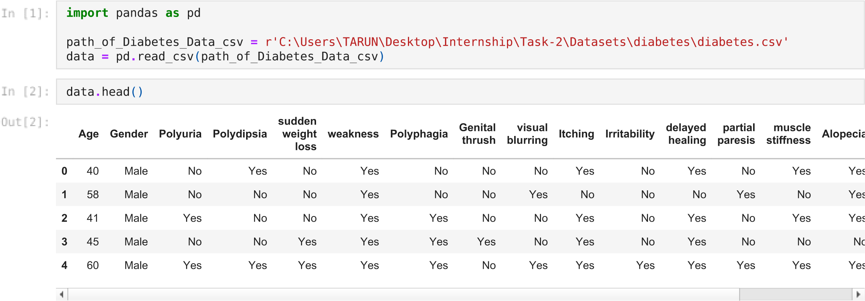

# ANALYSING DATASET

|  |
| --- |
| data**.**shape |

(520, 17)



|  |
| --- |
| data**.**isnull()**.**sum() |

Age 0



Gender 0

Polyuria 0 Polydipsia 0 sudden weight loss 0 weakness 0 Polyphagia 0 Genital thrush 0 visual blurring 0 Itching 0 Irritability 0 delayed healing 0 partial paresis 0 muscle stiffness 0 Alopecia 0 Obesity 0 class 0 dtype: int64

|  |
| --- |
| data**.**info() |

<class 'pandas.core.frame.DataFrame'> RangeIndex: 520 entries, 0 to 519 Data columns (total 17 columns):



# Column Non-Null Count Dtype

--- ------ -------------- -----

1. Age 520 non-null int64
2. Gender 520 non-null object
3. Polyuria 520 non-null object
4. Polydipsia 520 non-null object
5. sudden weight loss 520 non-null object
6. weakness 520 non-null object
7. Polyphagia 520 non-null object
8. Genital thrush 520 non-null object
9. visual blurring 520 non-null object
10. Itching 520 non-null object
11. Irritability 520 non-null object
12. delayed healing 520 non-null object
13. partial paresis 520 non-null object
14. muscle stiffness 520 non-null object
15. Alopecia 520 non-null object
16. Obesity 520 non-null object 16 class 520 non-null object dtypes: int64(1), object(16) memory usage: 69.2+ KB

**Age**

**count**

520.000000

**mean**

48.028846

**std**

12.151466

**min**

16.000000

**25**

**%**

39.000000

**50**

**%**

47.500000

**75**

**%**

57.000000

**max**

90.000000



data

**.**

describe

()



# DROPPING AND SELECTING FEATURES

subset **=** data[["Age", "Gender", "class"]]

subset**.**drop(subset[subset['class'] **==** 'Negative']**.**index, inplace**=True**) subset**.**drop('class', axis**=**1, inplace**=True**) subset**.**head()

**Age**

**Gender**

**0**

40

Male

**1**

58

Male

**2**

41

Male

**3**

45

Male

**4**

60

Male



<ipython-input-7-3abb4cd54897>:2: SettingWithCopyWarning:

A value is trying to be set on a copy of a slice from a DataFrame

See the caveats in the documentation: https://pandas.pydata.org/pandas-docs/stable/user_guide/indexing.html#retur ning-a-view-versus-a-copy subset.drop(subset[subset['class'] == 'Negative'].index, inplace=True)

<ipython-input-7-3abb4cd54897>:3: SettingWithCopyWarning:

A value is trying to be set on a copy of a slice from a DataFrame

See the caveats in the documentation: https://pandas.pydata.org/pandas-docs/stable/user_guide/indexing.html#retur ning-a-view-versus-a-copy subset.drop('class', axis=1, inplace=True)

# VISUALISATION

Text(0, 0.5, 'Number of patients')



**import**

matplotlib.pyplot

**as**

plt

fig

,

ax

**=**

plt

**.**

subplots

(

figsize

**=**

(

10

,

7

))

ax

**.**

hist

(

subset

**.**

loc

[

subset

[

'Gender'

]

**==**

'Male'

]

**.**

Age

,

bins

**=**

[

15

,

30

,

45

,

60

,

75

,

90

])

ax

**.**

set_title

(

'Diabetes Distribution for Male'

)

ax

**.**

set_xlabel

(

"AGE"

)

ax

**.**

set_ylabel

(

"Number of patients"

)

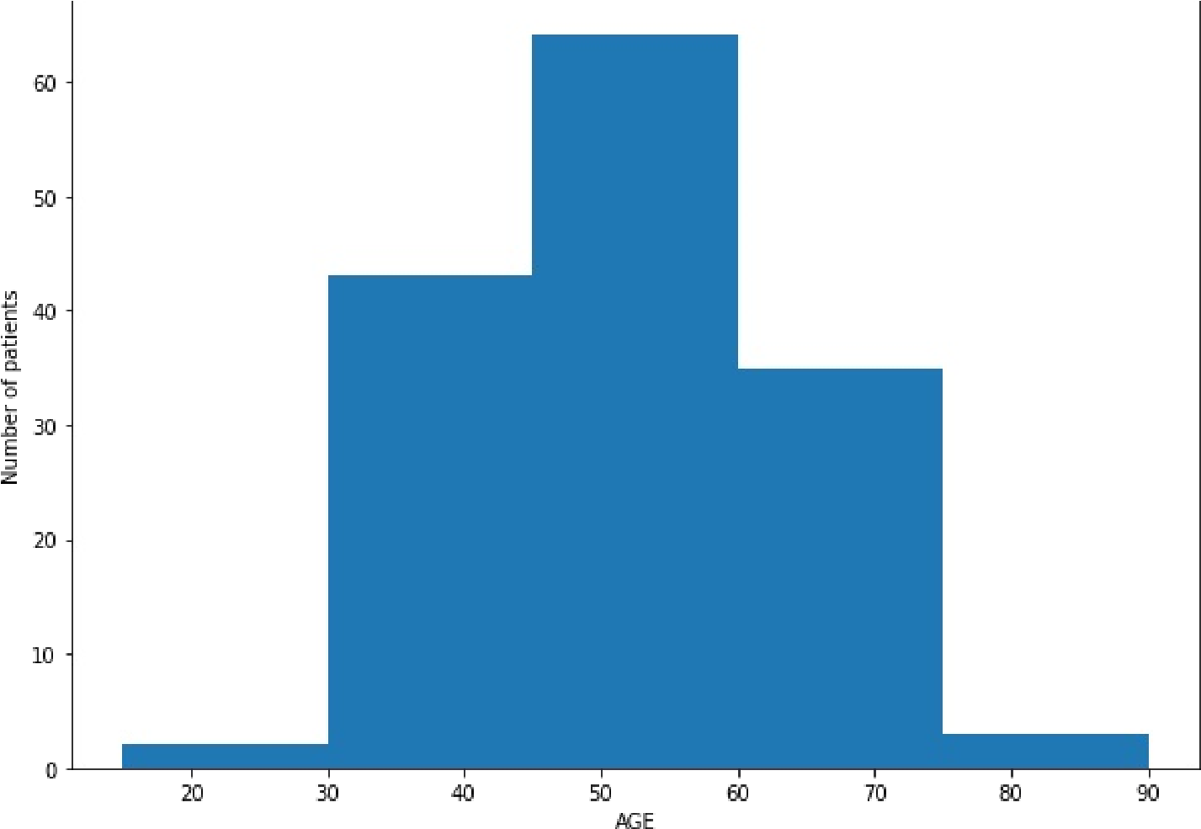

Text(0, 0.5, 'Number of patients')

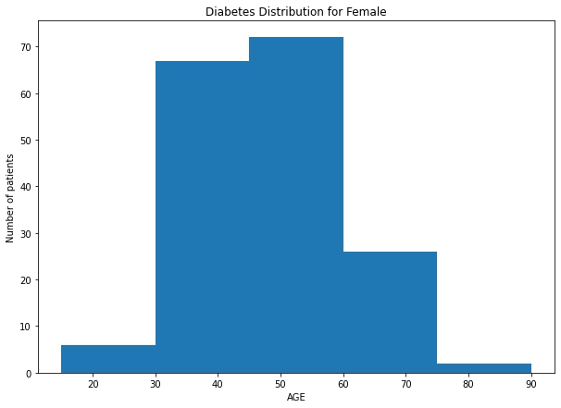

fig

,

ax

**=**

plt

**.**

subplots

(

figsize

**=**

(

10

,

7

))

ax

**.**

hist

(

subset

**.**

loc

[

subset

[

'Gender'

]

**==**

'Female'

]

**.**

Age

,

bins

**=**

[

15

,

30

,

45

,

60

,

75

,

90

])

ax

**.**

set_title

(

'Diabetes Distribution for Female'

)

ax

**.**

set_xlabel

(

"AGE"

)

ax

**.**

set_ylabel

(

"Number of patients"

)



<

AxesSubplot

:>

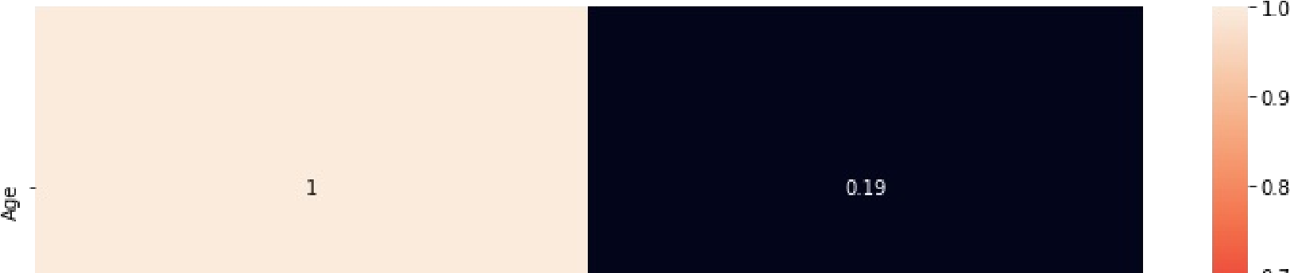

**from**

sklearn

**import**

preprocessing

le

**=**

preprocessing

**.**

LabelEncoder

()

df1

**=**

subset

**.**

apply

(

le

**.**

fit_transform

)



**import**

seaborn

**as**

sb

plt

**.**

figure

(

figsize

**=**

(

13

,

7

))

sb

**.**

heatmap

(

df1

**.**

corr

,

()

annot

**=**

**True**

)

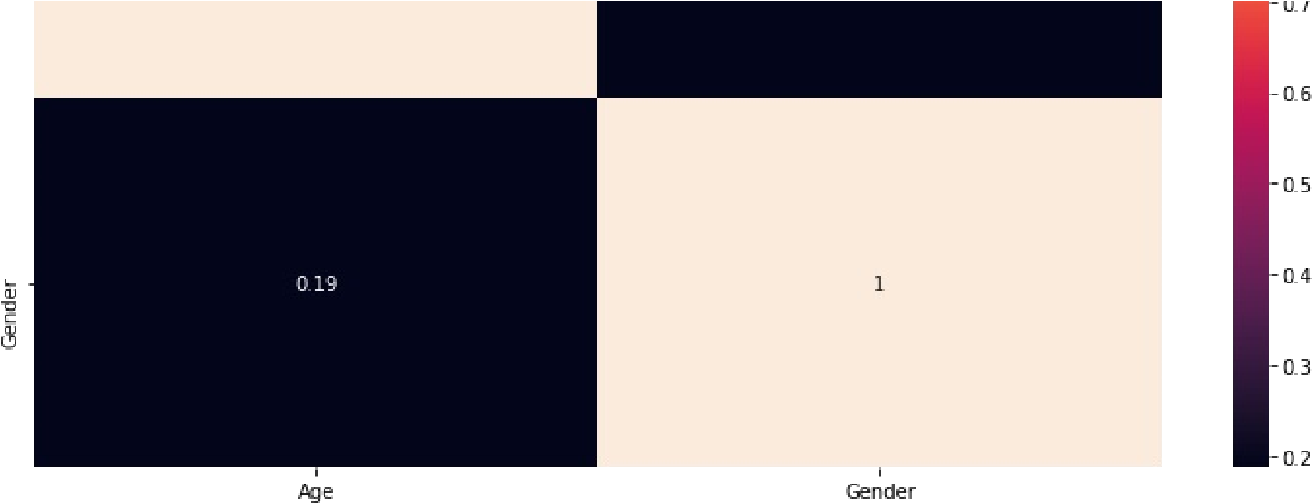

II

# READING DATASET

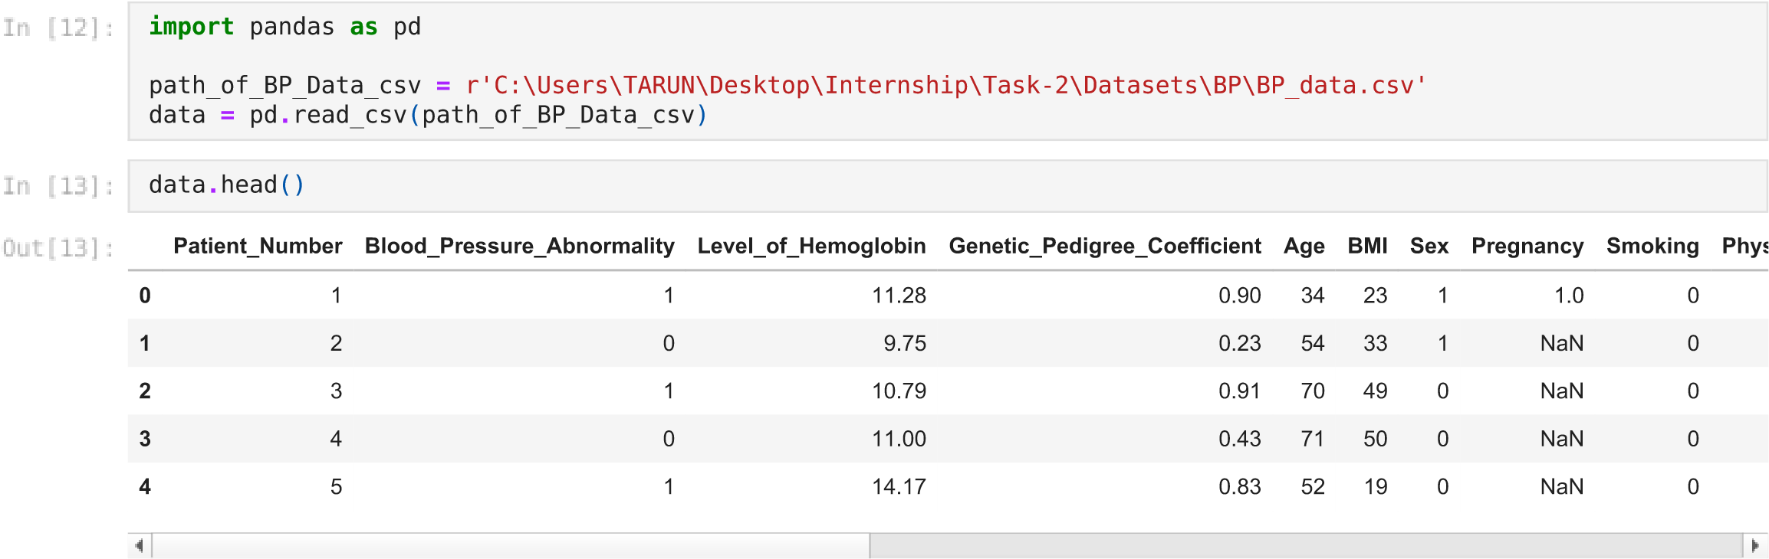

# ANALYSING DATASET

|  |
| --- |
| data**.**shape |

(2000, 15)



|  |
| --- |
| data**.**isnull()**.**sum() |

Patient_Number 0



Blood_Pressure_Abnormality 0

Level_of_Hemoglobin 0

Genetic_Pedigree_Coefficient 92

Age 0

BMI 0

Sex 0

Pregnancy 1558

Smoking 0 Physical_activity 0 salt_content_in_the_diet 0 alcohol_consumption_per_day 242 Level_of_Stress 0

Chronic_kidney_disease 0 Adrenal_and_thyroid_disorders 0 dtype: int64

|  |
| --- |
| data**.**info() |

<class 'pandas.core.frame.DataFrame'>



RangeIndex: 2000 entries, 0 to 1999

Data columns (total 15 columns):

# Column Non-Null Count Dtype

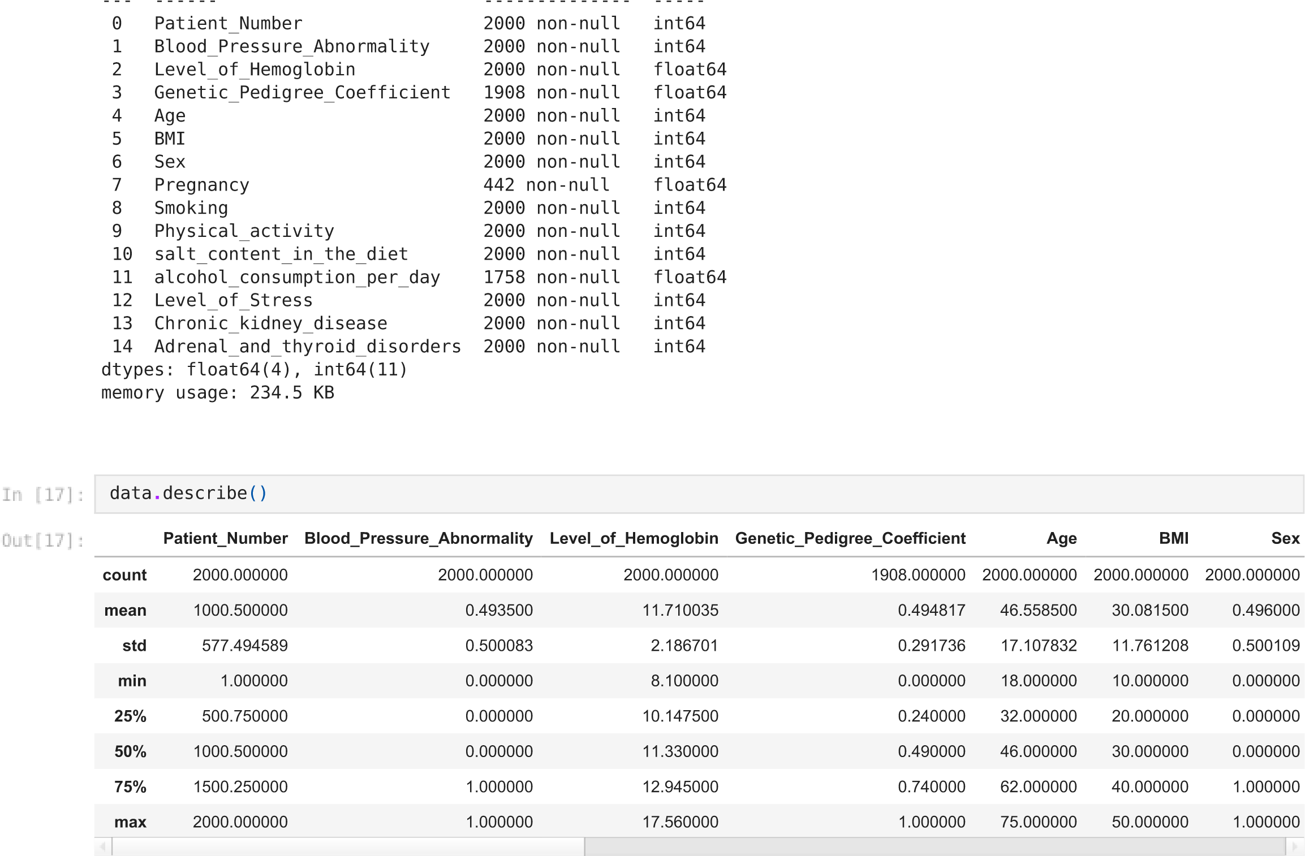

# DROPPING AND SELECTING FEATURES

|  |
| --- |
| *# removing pateints(rows) without diabets*  data**.**drop(data[data['Blood_Pressure_Abnormality'] **==** 0]**.**index, inplace **=** **True**)  *# selecting columns which are useful for segmentation* subset **=** data[["Age", "BMI", "alcohol_consumption_per_day"]] subset **=** subset**.**dropna() |

|  |
| --- |
| data**.**isnull()**.**sum() |

Patient_Number 0



Blood_Pressure_Abnormality 0

Level_of_Hemoglobin 0

Genetic_Pedigree_Coefficient 30

Age 0

BMI 0

Sex 0

Pregnancy 754

Smoking 0 Physical_activity 0 salt_content_in_the_diet 0 alcohol_consumption_per_day 146 Level_of_Stress 0

Chronic_kidney_disease 0 Adrenal_and_thyroid_disorders 0 dtype: int64

subset**.**head()

**Age**

**BMI**

**alcohol_consumption_per_day**

**2**

70

49

67.0

**4**

52

19

397.0

**6**

43

41

206.0

**9**

40

44

95.0

**10**

70

28

46.0



subset**.**describe()

**Age**

**BMI**

**alcohol_consumption_per_day**

**count**

841.000000

841.000000

841.000000

**mean**

49.665874

30.552913

254.123662

**std**

14.968185

11.689937

144.294990

**min**

25.000000

10.000000

0.000000

**25**

**%**

37.000000

21.000000

131.000000

**50**

**%**

49.000000

30.000000

252.000000

**%**

**75**

63.000000

41.000000

382.000000

**max**

75.000000

50.000000

499.000000



# VISUALISATION

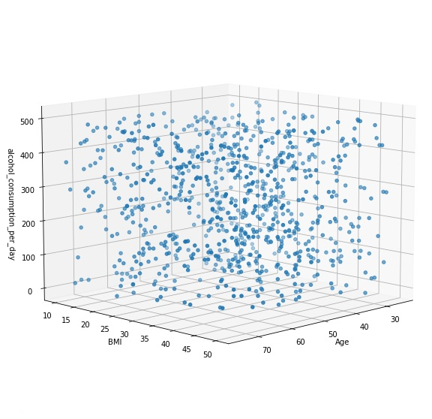

**import**

matplotlib.pyplot

**as**

plt



graph

**=**

plt

**.**

figure

(

figsize

**=**

(

10

,

10

))

**.**

gca

(

projection

**=**

'3d'

)

col1

,

col2

,

col3

**=**

'Age'

,

'BMI'

,

'alcohol_consumption_per_day'

graph

**.**

scatter

(

subset

[

col1

]

,

subset

[

col2

,

]

subset

[

col3

])

graph

**.**

set_xlabel

(

col1

)

graph

**.**

set_ylabel

(

col2

)

graph

**.**

set_zlabel

(

col3

)

graph

**.**

view_init

(

10

,

45

)

plt

**.**

show

()



<

AxesSubplot

:>

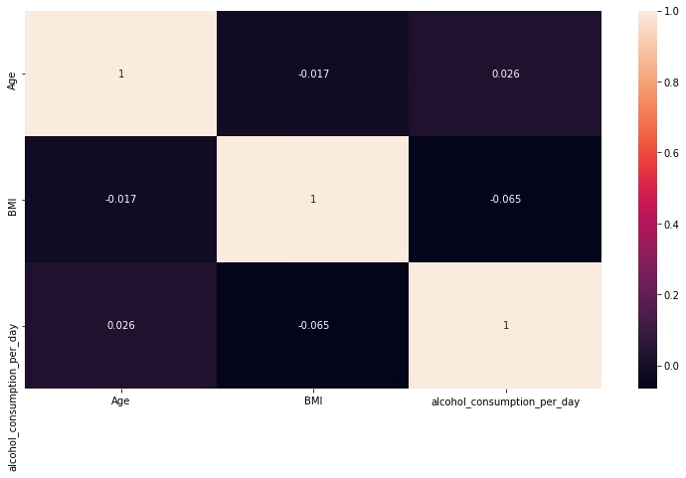

**from**

sklearn

**import**

preprocessing

le

**=**

preprocessing

**.**

LabelEncoder

()

df2

**=**

subset

**.**

apply

(

le

**.**

fit_transform

)



**import**

seaborn

**as**

sb

plt

**.**

figure

(

figsize

**=**

(

13

,

7

))

sb

**.**

heatmap

(

df2

**.**

corr

()

,

annot

**=**

**True**

)

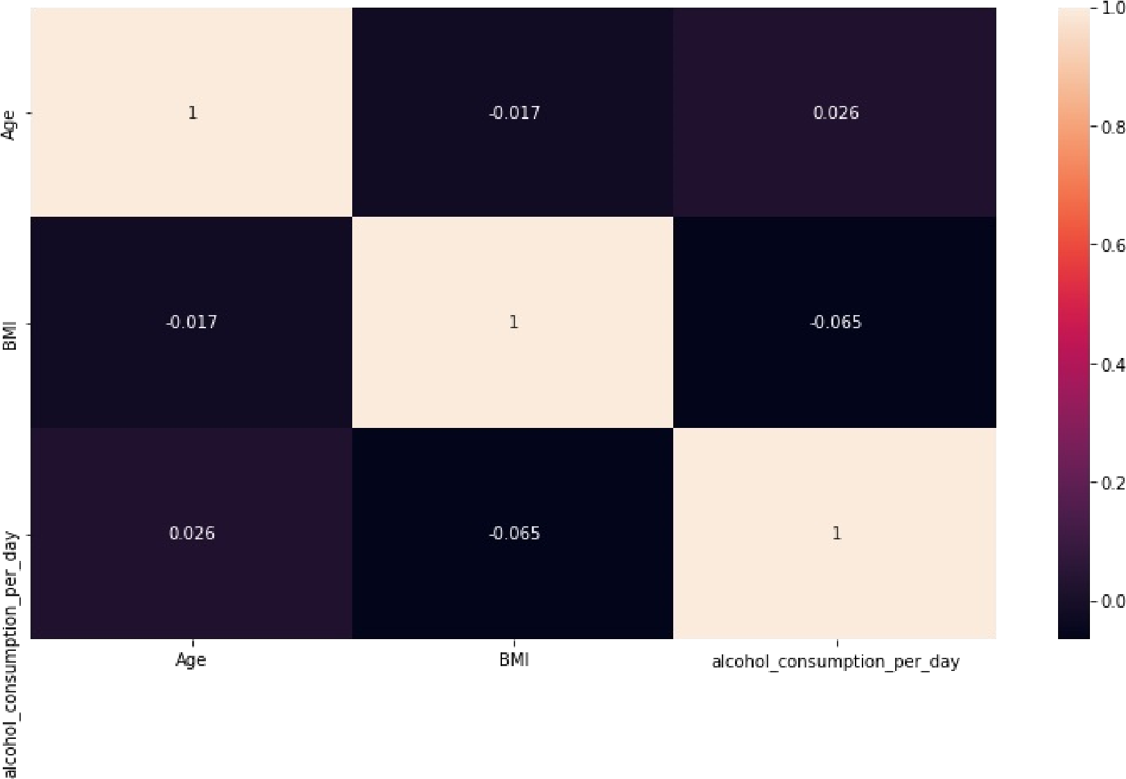

# K-MEANS CLUSTERING

|  |
| --- |
| **from** sklearn.cluster **import** KMeans **from** matplotlib **import** pyplot **as** plt **import** numpy **as** np X**=**np**.**array(df2) |

|  |
| --- |
| kmeans**=**KMeans(n_clusters**=**3) kmeans**.**fit(X)  y_kmeans**=**kmeans**.**predict(X) print(y_kmeans) |

[1 0 2 1 1 0 1 0 0 1 0 1 0 2 2 2 0 2 0 2 2 2 1 2 1 1 2 0 0 2 0 1 0 1 0 2 0



2 0 0 2 1 0 2 1 0 2 0 1 0 2 1 2 2 2 0 2 0 2 1 0 2 1 1 2 1 1 2 0 1 1 0 0 0

1 1 2 0 0 1 1 0 2 1 0 0 0 0 0 1 2 0 2 0 0 1 1 0 0 0 0 1 0 0 2 2 2 1 1 2 1

1. 1 2 2 2 0 2 0 2 2 2 1 2 2 2 1 2 1 0 0 0 2 2 1 2 2 0 2 2 0 0 2 0 2 0 0 0
2. 1 2 0 2 2 1 1 1 1 1 1 0 1 0 0 0 2 0 2 1 0 0 1 1 1 1 2 1 2 1 2 1 1 1 2 2

1 1 2 1 1 2 0 1 2 0 0 1 0 2 1 2 2 0 1 2 0 1 0 0 1 1 2 2 2 2 0 1 0 0 0 0 1

0 0 2 2 0 0 2 1 0 2 0 0 2 1 0 0 0 1 1 2 2 1 2 0 0 0 0 1 1 0 1 0 2 0 2 1 0

2 0 2 1 2 1 1 2 0 0 1 2 1 2 1 0 1 0 0 0 2 2 1 1 1 0 1 2 0 0 2 0 1 2 1 2 0

0 2 1 0 0 1 0 1 1 2 0 2 1 1 0 0 2 0 0 2 0 2 0 0 2 0 2 0 0 2 0 1 2 2 0 0 0

2 1 0 2 0 1 2 1 1 2 0 1 1 2 0 0 2 0 0 1 2 1 1 1 2 0 1 0 2 2 2 0 0 0 1 0 1

2 0 1 2 1 0 2 2 2 0 1 1 1 1 1 2 1 2 1 1 0 0 0 0 0 0 1 1 1 1 1 1 1 2 2 0 1

1. 0 0 1 0 1 2 0 2 2 2 0 2 1 2 0 2 0 2 2 1 2 1 2 1 1 2 2 1 2 2 1 0 1 1 0 1
2. 0 0 2 2 0 1 0 2 2 1 1 1 1 1 0 1 2 0 2 2 0 0 1 0 2 2 1 0 0 0 0 2 0 2 0 1

2 2 2 0 0 1 2 0 0 2 0 2 0 2 1 0 1 2 2 0 1 1 2 1 2 0 0 0 0 2 0 1 2 1 0 0 0

2 1 1 1 1 0 1 2 0 2 2 0 2 2 0 2 2 2 1 0 2 0 0 1 2 2 0 0 1 0 1 1 0 1 0 2 2

0 1 0 1 2 1 1 2 1 0 1 1 0 0 0 2 2 1 1 2 2 2 2 2 1 1 2 0 1 1 1 2 0 0 0 1 1

0 2 1 2 2 1 2 1 2 0 0 1 0 0 2 1 1 2 1 1 0 2 0 0 2 2 1 2 2 1 0 1 1 1 2 2 1

0 0 0 2 0 1 1 0 1 2 1 1 2 1 2 1 1 0 1 0 0 2 1 0 2 1 1 1 0 1 2 0 1 2 0 0 2

0 2 2 1 0 1 2 0 1 1 2 0 1 1 0 2 1 2 0 2 2 2 1 2 2 0 0 2 1 0 1 1 0 2 2 2 1

2 1 1 0 2 1 0 1 0 0 2 1 0 0 2 2 0 0 2 0 0 1 0 0 0 1 0 2 1 2 2 0 0 0 0 0 2

1. 0 0 2 1 2 2 2 0 2 1 0 2 0 2 2 0 0 2 2 1 2 0 0 0 1 2 1 2 0 2 1 1 1 0 2 1
2. 0 0 1 2 0 0 2 0 1 1 0 2 1 1 1 2 2 2 1 2 2 1 0 0 2 1 1 2 2 0 0 2 2 1 1 1

0 1 0 0 2 2 1 2 0 1 1 2 1 0 0 1 1 2 0 0 2 1 1 1 1 1 2]

|  |
| --- |
| print(kmeans**.**cluster_centers_) |

[[ 24.82312925 19.62585034 349.71428571]



[ 24.11355311 21.76923077 67.65934066]

[ 25.04744526 20.33576642 203.28832117]]

|  |  |  |
| --- | --- | --- |
|  | |  | | --- | | plt**.**scatter(X[:,1],X[:,2],c**=**y_kmeans) centers**=**kmeans**.**cluster_centers_  plt**.**scatter(centers[:,1],centers[:,2],c**=**'red') | |

<

matplotlib.collections.PathCollection at 0x266c56398e

0>

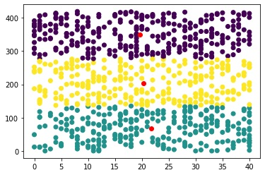

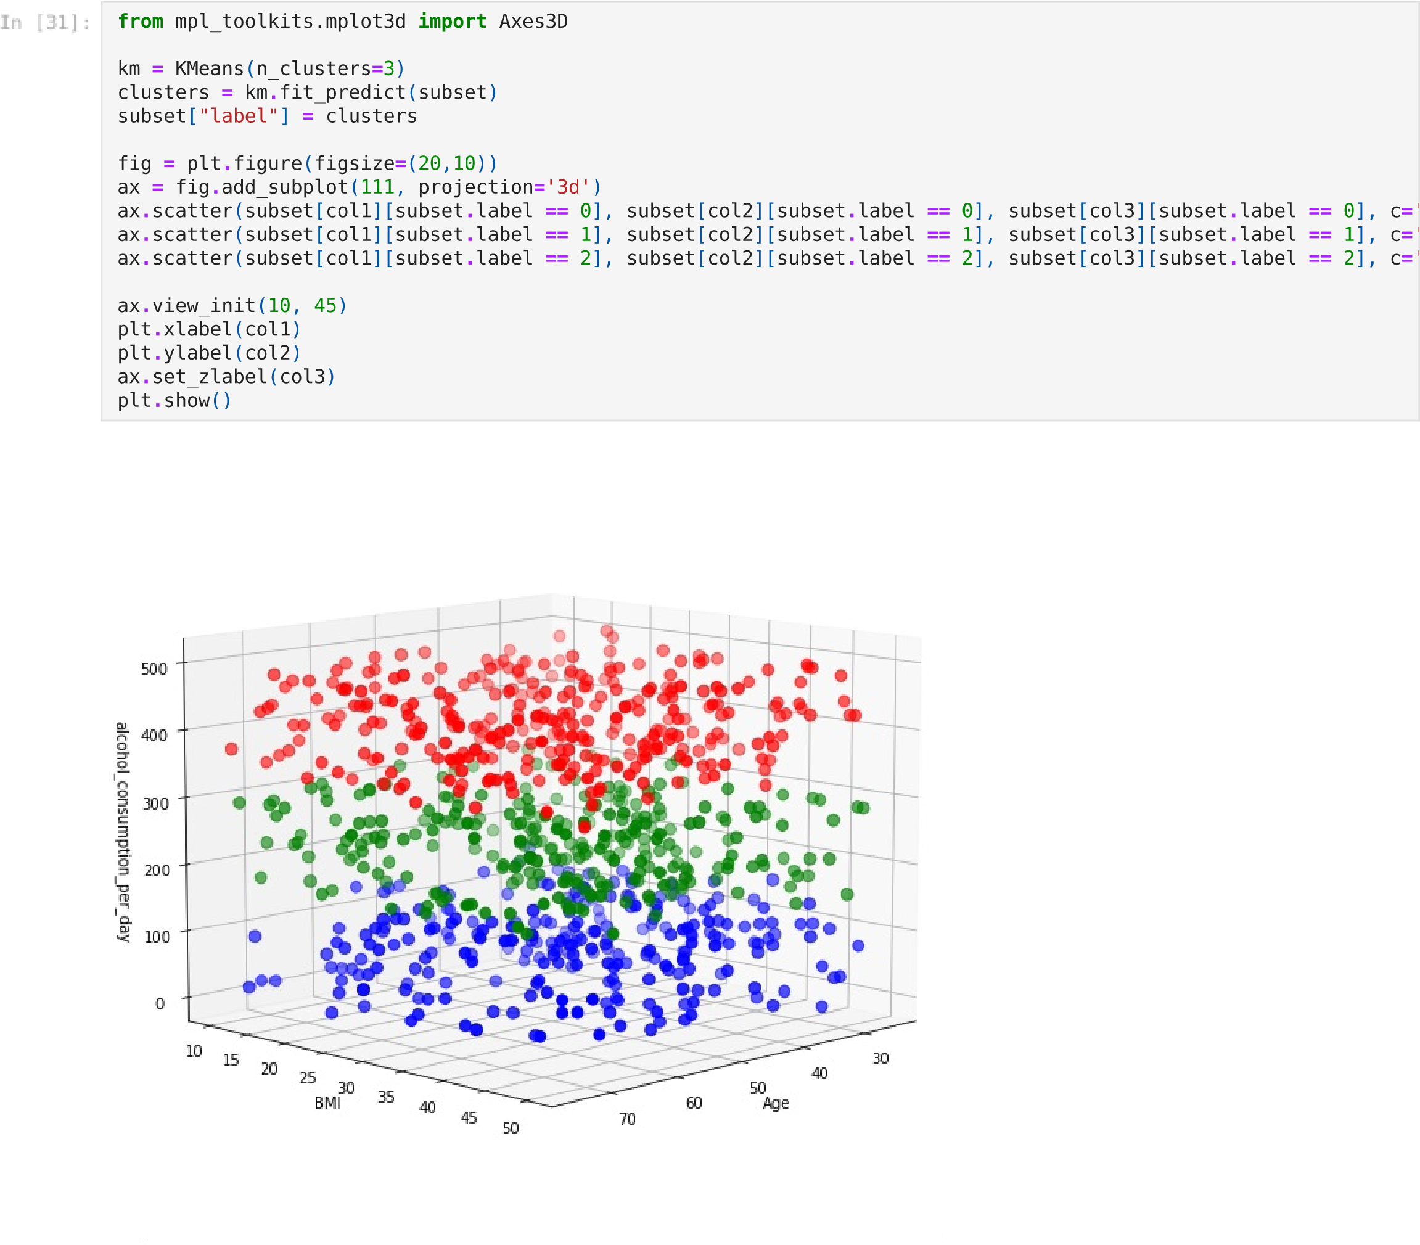

III

# READING DATA



**import**

pandas

**as**

pd

path_of_BP_Data_csv

**=**

r

"C:\Users\TARUN\Desktop\Internship\Task-2\Datasets\Vitamin\vitamins_data.csv"

data

**=**

pd

**.**

read_csv

(

path_of_BP_Data_csv

)



data**.**head()

**State**

**Population(0-6)years**

**VitA_deficit%**

**VitD_deficit%**

**0**

India

163819614

17.6

13.8

**1**

Delhi

2016849

17.8

32.5

**2**

Haryana

3335537

26.1

27.6

**3**

Himachal Pradesh

793137

5.9

4.6

**4**

Jammu & Kashmir

1485803

8.7

22.9



# ANALYSING DATASET

data**.**isnull()**.**sum()

(31

,

4)

State 0

Population(0-6)years 0

VitA_deficit% 2

VitD_deficit% 0

dtype: int64

class 'pandas.core.frame.DataFrame'

>

<

RangeIndex: 31 entries, 0 to 30

Data columns (total 4 columns):

# Column Non-Null Count Dtype

------ -------------- -----

---

0 State 31 non-null object

1 Population(0-6)years 31 non-null int64

2 VitA_deficit% 29 non-null float64

3 VitD_deficit% 31 non-null float64

dtypes: float64(2), int64(1), object(1)

memory usage: 1.1+ KB

**Population(0-6)years**

**VitA_deficit%**

**VitD_deficit%**

**count**

31.00000

29.00000

31.00000

**mean**

10622915.22581

17.43103

15.79355

**std**

29193291.30761

9.73378

13.26670

**min**

78195.00000

2.40000

1.10000

**%**

**25**

630558.00000

9.60000

6.10000

**50**

**%**

3554916.00000

17.10000

12.80000

**75**

**%**

8852130.50000

21.40000

22.80000

**max**

163819614.00000

43.20000

52.10000



data

**.**

shape



data

**.**

describe

()

**.**

apply

(

**lambda**

s

:

s

**.**

apply

(

'

{0:.5f}

'

**.**

format

))



data**.**info()

# DROPPING ROWS HAVING NULL VALUES

|  |
| --- |
| VitA **=** data[["State", "VitA_deficit%"]]  VitA **=** VitA**.**dropna()  VitA**.**drop(VitA[VitA**.**State **==** 'India']**.**index, inplace**=True**) VitA**.**head() |

|  |  |
| --- | --- |
| **1** Delhi | 17.8 |
| **2** Haryana | 26.1 |

**State VitA_deficit%**



|  |  |  |
| --- | --- | --- |
| **4** | Jammu & Kashmir | 8.7 |
| **5** | Punjab | 17.2 |

 **3** Himachal Pradesh 5.9

# VISUALISATION

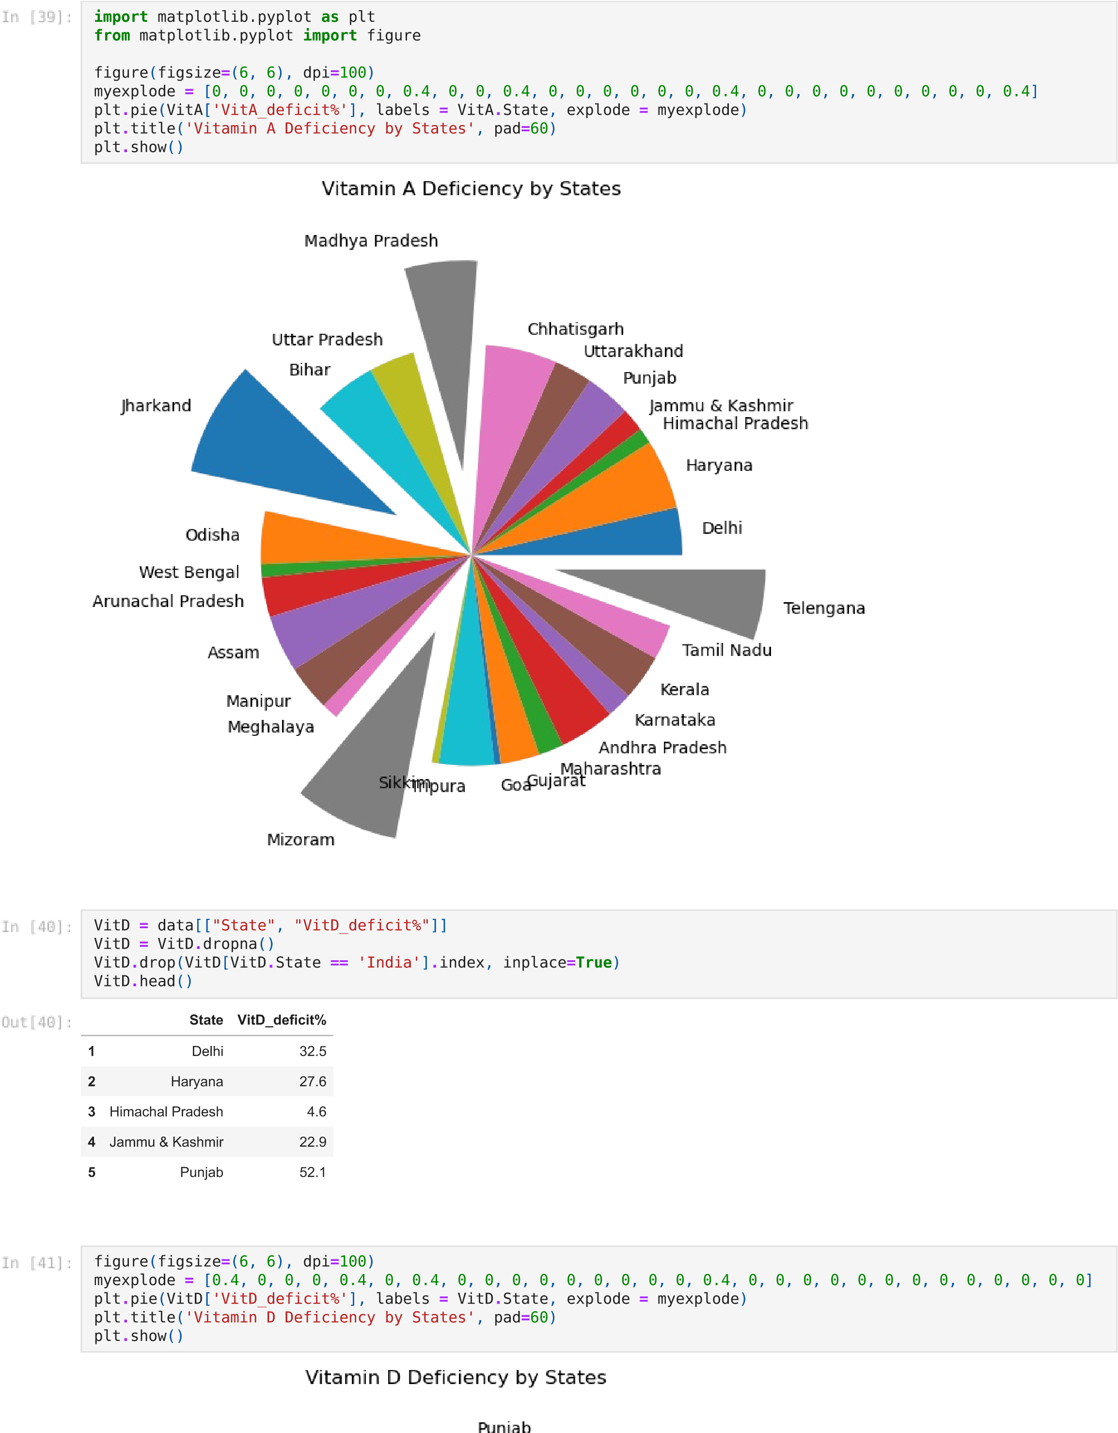

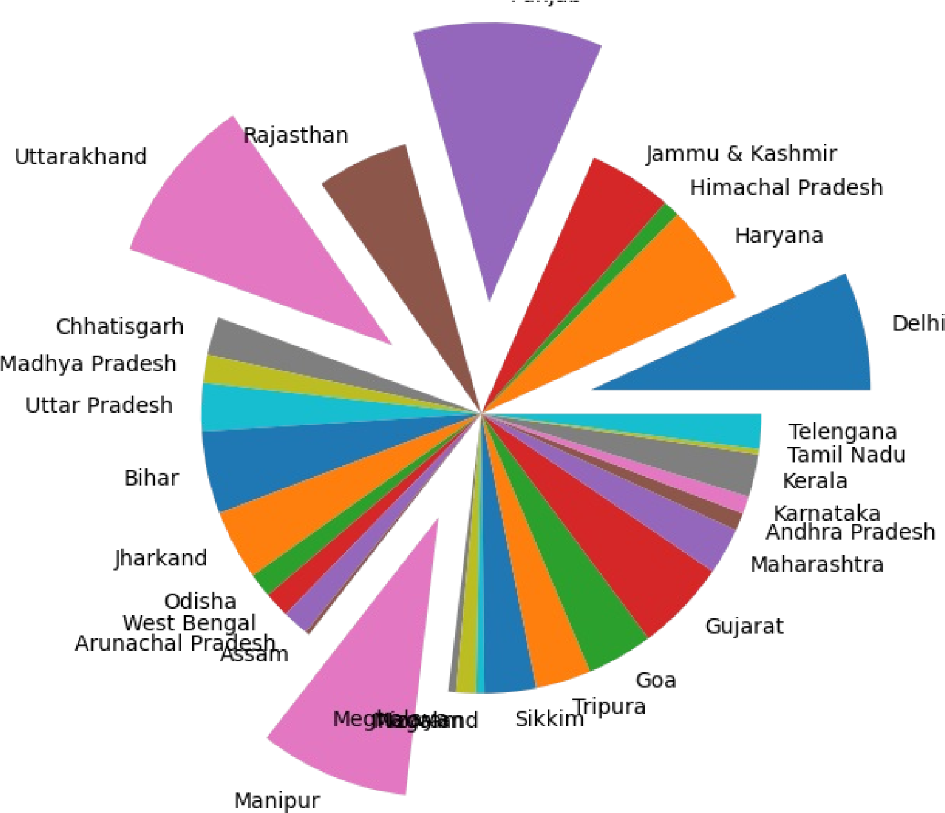

IV

# READING DATASET

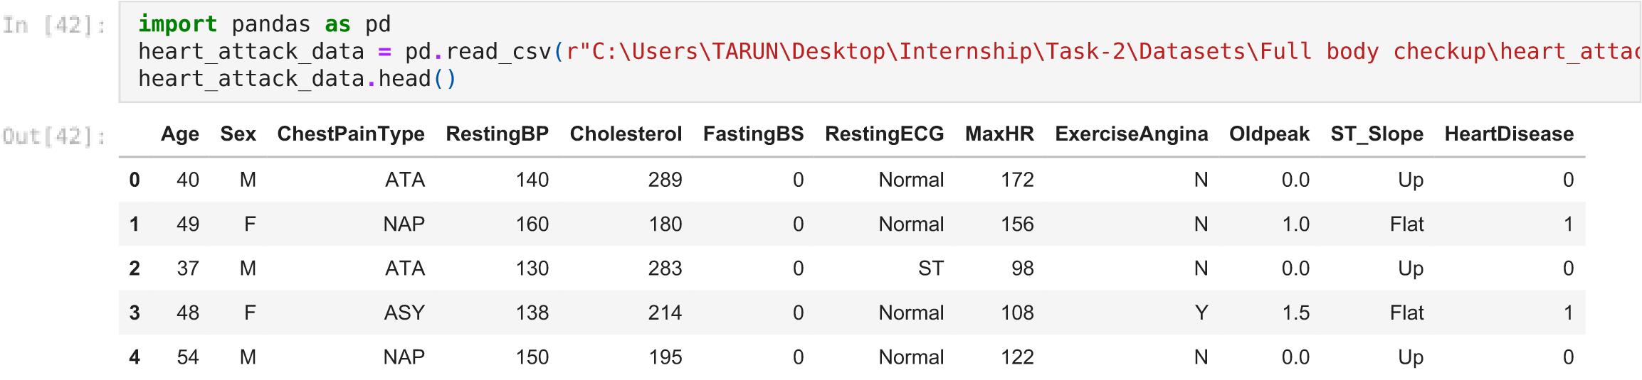

# ANALYSING DATASET

|  |
| --- |
| heart_attack_data**.**shape |

(918, 12)



|  |
| --- |
| heart_attack_data**.**isnull()**.**sum() |

Age 0



Sex 0

ChestPainType 0

RestingBP 0

Cholesterol 0

FastingBS 0

RestingECG 0

MaxHR 0

ExerciseAngina 0

Oldpeak 0

ST_Slope 0 HeartDisease 0 dtype: int64

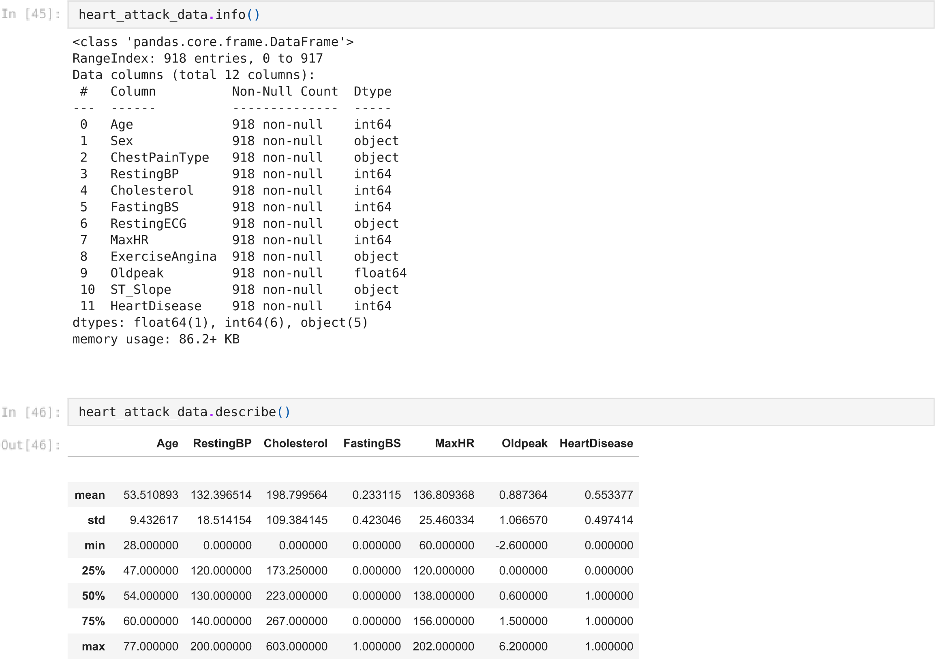**count** 918.000000 918.000000 918.000000 918.000000 918.000000 918.000000 918.000000

# DROPPING AND SELECTING FEATURES

|  |
| --- |
| *# removing pateints(rows) without diabets*  heart_attack_data**.**drop(heart_attack_data[heart_attack_data['HeartDisease'] **==** 0]**.**index, inplace **=** **True**)  *#selecting columns for subset*  subset **=** heart_attack_data[["Age","Cholesterol","MaxHR"]] subset **=** subset**.**dropna() subset**.**head() |

subset**.**describe()

**Age**

**Cholesterol**

**MaxHR**

**1**

49

180

156

**3**

48

214

108

**8**

37

207

130

**11**

58

164

99

**13**

49

234

140

**Age**

**Cholesterol**

**MaxHR**

**count**

508.000000

508.000000

508.000000

**mean**

55.899606

175.940945

127.655512

**std**

8.727056

126.391398

23.386923

**min**

31.000000

0.000000

60.000000

**25**

**%**

51.000000

0.000000

112.000000

**%**

**50**

57.000000

217.000000

126.000000

**75**

**%**

62.000000

267.000000

144.250000



|  |  |  |  |
| --- | --- | --- | --- |
| **max** | 77.000000 | 603.000000 | 195.000000 |

# VISUALISATION

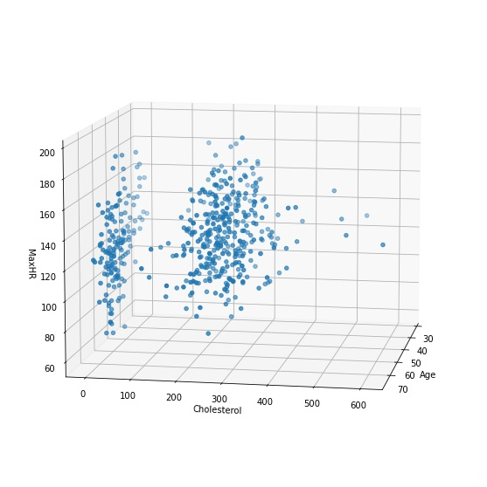

**import**

matplotlib.pyplot

**as**

plt



graph

**=**

plt

**.**

figure

(

figsize

**=**

(

10

,

10

))

**.**

gca

(

projection

**=**

'3d'

)

col1

,

col2

,

col3

**=**

'Age'

,

'Cholesterol'

,

'MaxHR'

graph

**.**

scatter

(

subset

[

col1

]

,

subset

[

col2

,

]

subset

[

col3

])

graph

**.**

set_xlabel

(

col1

)

graph

**.**

set_ylabel

(

col2

)

graph

**.**

set_zlabel

(

col3

)

graph

**.**

view_init

(

10

,

10

)

plt

**.**

show

()



<

AxesSubplot

:>

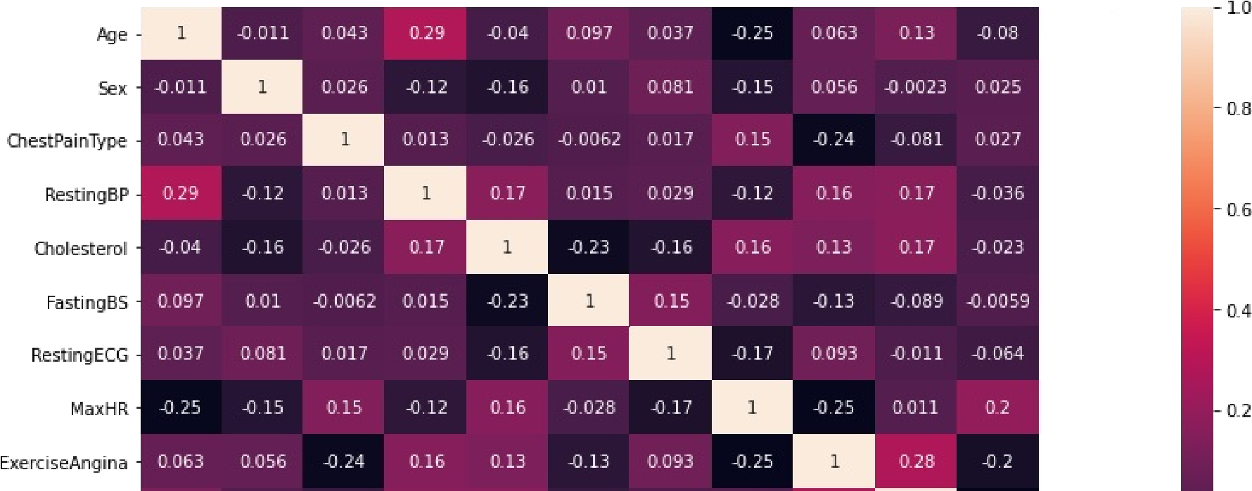

**from**

sklearn

**import**

preprocessing

le

**=**

preprocessing

**.**

LabelEncoder

()

df4

**=**

heart_attack_data

**.**

apply

(

le

**.**

fit_transform

)



**import**

seaborn

**as**

sb

plt

**.**

figure

(

figsize

**=**

(

13

,

7

))

sb

**.**

heatmap

(

df4

**.**

corr

,

()

annot

**=**

**True**

)

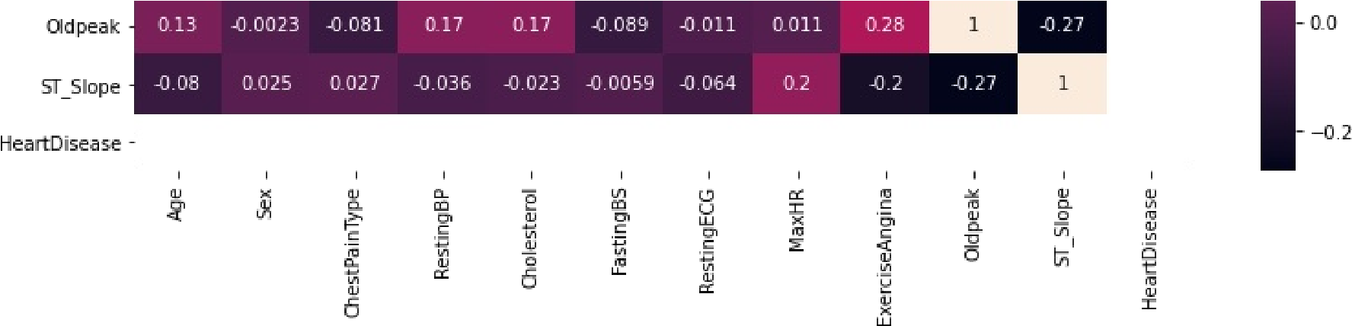

# K-MEANS CLUSTERING

|  |
| --- |
| **from** sklearn.cluster **import** KMeans **from** matplotlib **import** pyplot **as** plt **import** numpy **as** np X**=**np**.**array(df4) |

|  |
| --- |
| kmeans**=**KMeans(n_clusters**=**3) kmeans**.**fit(X)  y_kmeans**=**kmeans**.**predict(X) print(y_kmeans) |

[2 1 1 2 1 1 1 0 0 0 1 2 0 0 2 0 1 1 0 1 0 0 1 0 2 0 0 1 1 1 2 1 0 0 1 0 0



1. 2 1 1 0 0 2 1 0 1 0 1 0 2 1 0 0 0 0 0 0 1 0 1 1 0 1 0 0 1 1 0 1 1 0 1 1
2. 1 0 1 0 1 0 0 2 0 0 0 2 1 0 0 1 0 1 0 0 1 1 1 2 1 0 1 1 2 1 1 2 2 2 2 2
3. 2 2 2 2 2 2 2 2 2 2 2 2 2 2 2 2 2 2 2 2 2 2 2 2 2 2 2 2 2 2 2 2 2 2 2 2

2 2 2 2 2 2 2 2 2 2 2 2 2 2 2 2 2 2 2 2 2 2 2 2 2 2 2 2 2 2 2 2 2 2 2 2 2

2 2 2 2 2 2 2 2 2 2 2 2 2 2 2 2 2 2 2 2 2 2 2 2 2 2 2 2 2 2 2 2 2 2 2 2 1

1. 1 1 2 0 2 2 2 2 2 1 2 2 2 2 2 2 2 2 1 2 2 1 2 2 2 0 1 2 2 2 0 2 1 2 2 2
2. 2 2 0 2 2 0 2 2 2 0 2 2 1 1 1 1 1 2 0 1 0 1 0 0 1 0 1 1 1 1 2 1 0 1 2 1

1 2 0 0 0 2 0 2 1 1 0 2 1 1 2 2 1 1 1 2 0 1 1 1 1 1 1 1 1 1 1 0 1 0 0 1 0

1 1 2 1 2 1 0 2 0 2 0 2 1 1 1 0 1 1 1 0 1 1 2 1 1 1 0 0 0 1 0 2 0 0 1 1 0

1 1 1 0 0 1 0 1 1 1 1 0 1 1 1 0 1 1 2 1 1 1 0 2 1 0 0 0 0 1 1 0 1 1 0 1 0

0 1 1 0 1 1 0 1 0 1 2 0 0 1 0 0 2 0 0 0 1 0 1 1 1 1 1 0 0 1 2 1 1 1 1 1 1

0 1 0 0 0 1 1 0 2 2 0 2 0 0 0 1 0 0 0 0 1 1 1 0 1 0 0 1 1 2 2 0 0 1 1 2 0

2 0 0 0 1 0 1 0 1 1 1 1 0 1 1 0 1 1 2 1 1 2 1 1 1 2 1]

|  |
| --- |
| print(kmeans**.**cluster_centers_) |

[[ 23.93283582 0.82835821 0.42537313 32.53731343 128.40298507



0.23880597 0.91791045 55.68656716 0.70895522 22.2238806 1.03731343 0. ]

[ 25.67977528 0.91573034 0.46629213 29.16292135 66.43258427

0.24157303 0.97191011 54.16292135 0.64606742 21.61797753 1.0505618 0. ]

[ 24.85204082 0.93877551 0.44897959 26.18367347 4.2244898

0.48469388 1.1377551 46.28571429 0.54081633 18.17346939 1.07653061 0. ]]

<

matplotlib.collections.PathCollection at

0x266c71c1460>

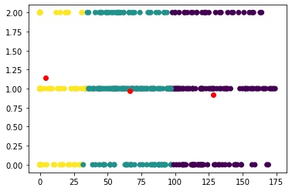

plt

**.**

scatter

(

X

,

[:

4

,

]

X

[:

,

6

]

,

c

**=**

y_kmeans

)

centers

**=**

kmeans

**.**

cluster_centers_

plt

**.**

scatter

(

centers

[:

,

4

]

,

centers

[:

,

6

]

,

c

**=**

'red'

)



**from**

mpl_toolkits.mplot3d

**import**

Axes3D

